Customer Segmentation Report
Project Title: Customer Segmentation Using K-Means Clustering
Data Source: Customer Support Tickets Dataset
Tools Used: Python, Pandas, Scikit-learn, Matplotlib, Seaborn, PCA

1. Executive Summary (Top-Level Takeaway)
This project segments customers into four clear behavioral and demographic groups using K-Means clustering.
The major driver of dissatisfaction is long resolution time, followed by technical issue frequency.
These insights guide improvements in support operations, efficiency, and targeted customer strategies.

2. Project Objective
The main goal is to identify distinct customer groups based on demographics and support interaction behavior using clustering techniques.
This helps the business:
- Improve customer experience
- Reduce operational inefficiencies
- Predict potential dissatisfaction
- Personalize communication
- Allocate support resources strategically

3. Business Questions Answered
Customer Demographics
- What age groups raise more tickets?
- What age group is having quick response?
- Which gender has lower satisfaction?
- Do demographics influence ticket type?
Ticket Behavior
- Which issue types are most common?
- How does priority affect resolution time?
- Which channels are used the most?
Experience & Satisfaction
- What factors reduce CSAT?
- Which product issues drive dissatisfaction?
Cluster Analysis
- Which customers need urgent support focus?
- What behavioral traits define each cluster?

4. Data Understanding & Cleaning
Cleaning Steps Performed:
✔ Removed duplicate tickets
✔ Parsed dates into datetime formats
✔ Converted durations into hours
✔ Handled missing CSAT values
✔ Encoded categorical columns
✔ Aggregated to customer-level features

5. EDA Summary
Univariate Analysis
A. Customer Demographics
- Age: Histogram, mean/median; identifies common age range & active ticket-raising groups.
- Gender: Value counts & pie chart showing distribution.
B. Ticket Metadata
- Ticket Type: Top 5 most frequent issue types.
- Priority: Distribution of Low/Medium/High/Critical tickets.
- Channel: Usage frequency of Email, Phone, Chat, Social Media.
Bivariate Analysis
- Priority vs Resolution Time: Boxplot to check if high-priority tickets are resolved faster.
- Ticket Type vs CSAT: Average CSAT per issue type.
- Channel vs CSAT: Satisfaction comparison across channels.
- Age vs CSAT: Relationship between customer age and satisfaction score.
Text Analysis
- Keyword extraction from ticket text (login, refund, payment, setup).
- Word cloud for top complaint themes.
- Identifies frequent problem categories.
Time-Based EDA
- Monthly/Yearly ticket trends.
- Monthly average resolution time.
- Detects seasonal peaks & performance dips.
Product-Based EDA
- Tickets per product.
- Average CSAT per product.
- Resolution time across products.
- Highlights high-issue and low-satisfaction products.
6. K-Means clustering
Imported Libraries
Python libraries, pandas for data handling, matplotlib for plotting, and KMeans from sklearn for clustering.”
Converting ‘First Response Time’ into Hours
First Response Time into proper datetime using pd.to_datetime().
New column ‘First Response Hours’ calculating how many hours passed from the earliest response time for converting time into a number so that K-means can understand it.
Features for Clustering
- Customer Age
- First Response Hours
K-Means Clustering
(Cluster 0, Cluster 1, and Cluster 2) based on two things: their Age and the First Response Time
Output

Cluster | Color | Customer Age Range | Interpretation
Cluster 1 | 🟢 Green | All Ages (Mostly 30+) | who had to wait a very long time for a first response (about a month). This group has a service issue.
Cluster 0 & 2 | 🔴 Red 🔵 Blue | Young and Older Ages (45+) | The Satisfied Groups (Fast Service): These two groups both received a very fast response time, (within the first day).
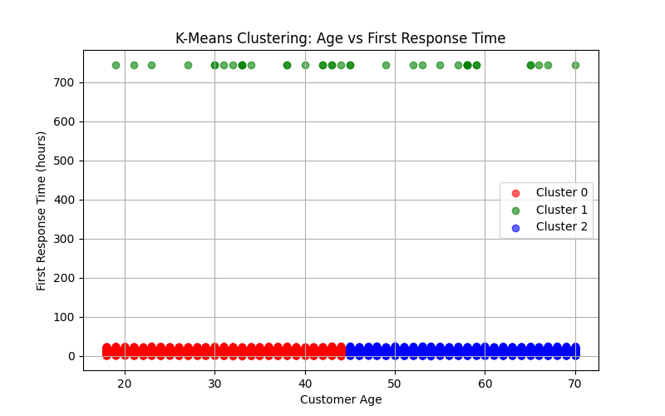

Cluster 0
Number of customers: 4261
Average Response Time (hours): 13
Cluster 1
Number of customers: 38
Average Response Time (hours): 744
Cluster 2
Number of customers: 4170
Average Response Time (hours): 14

7.Elbow Method and Silhouette Score
Elbow Method
Calculating the WCSS (within-cluster sum of squares) for cluster numbers from 1 to 10.
It helps to find “elbow point,” which shows the best number of clusters.
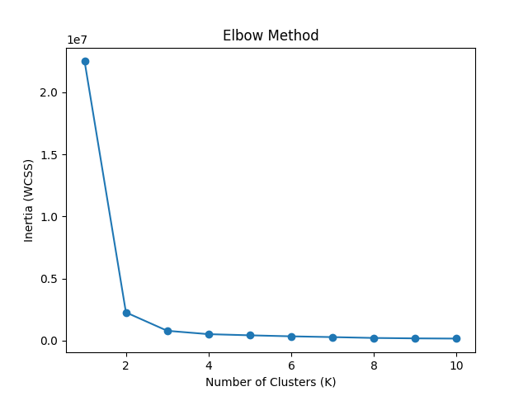
- Plotted K (1 to 10) vs Inertia using a line graph.
- The graph shows a sharp drop at first, then the curve flattens.
- The point where it starts flattening is called the elbow, which suggests the optimal number of clusters.”
Result:
In the graph, sharp drop happens at K=2. After K=2, the decrease is gradual, the elbow is at 2 clusters.
- One cluster with fast response customers
- One cluster with slow response customers
Silhouette Score
- The Silhouette Score plot shows how well the data forms clusters for values of K from 2 to 10.
- K = 3 achieves the highest score (0.222), indicating the best overall cluster separation and cohesion.
- K = 2 also performs well (0.218), showing that the data naturally forms 2–3 strong groups.
- A sharp drop at K = 4 (0.157) suggests weaker separation when forcing more clusters.
- Scores for K > 5 remain relatively low and stable, meaning additional clusters do not improve structure.
- Overall, the visual confirms that 3 clusters is mathematically optimal, while higher K values provide diminishing returns.
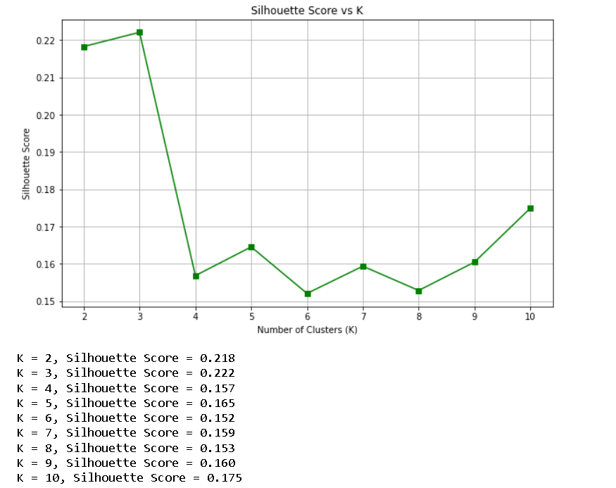

8. Visualization Insights
PCA Cluster Plot
- The PCA visualization shows clear grouping of customers into distinct clusters based on their behavior and ticket patterns.
- One cluster appears separate and compact, indicating customers with very similar characteristics.
- The remaining clusters overlap slightly but still show meaningful separation, confirming that the K-Means model successfully identifies different customer segments.
- PCA reduces complex features into two main components, making the clusters easy to interpret visually.
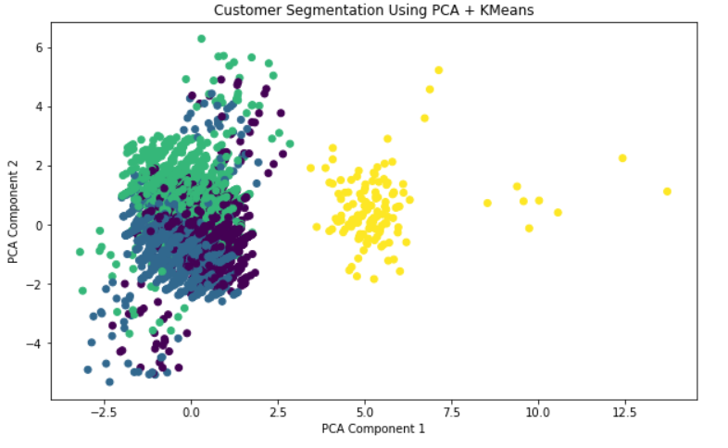

9. Key Insights
- Long resolution time is the biggest enemy of CSAT.
- The middle age grouped customers are facing long waiting hours for their first response.
- Technical issues generate the highest dissatisfaction.
- Chat channel leads to fastest responses.
- Billing workflows need better automation.
- A small group of customers contributes to a large share of tickets.
- Multi-product users have strong revenue potential.

10. Recommendations
A. Improve Customer Satisfaction
- Prioritize technical issues with dedicated specialists
- Implement “Resolution SLA Guarantee”
- Expand chat-first policy
B. Optimize Operations
- Build automated flows for repetitive technical issues
- Improve ticket routing based on cluster type
- Strengthen billing documentation & training
C. Targeted Retention & Marketing
- Upsell multi-product users (Cluster 3)
- Launch loyalty rewards (Cluster 1)
- Reduce churn risk for Cluster 0 via proactive outreach
D. Product Improvement
- Identify frequently failing components
- Create guided self-service troubleshooters
- Assign product managers to top issue categories

11. Limitations
- No revenue or churn labels
- Text data not deeply analyzed (needs NLP)
- No behavioral time patterns like session logs

12. Conclusion
This segmentation provides a strong foundation for improving customer satisfaction, optimizing support operations, and designing targeted retention strategies.
The insights reveal clear opportunities for cost reduction, service quality improvement, and customer value enhancement.

